**電通二乙微處理器實驗 實驗結報**

|  |  |  |  |
| --- | --- | --- | --- |
| **實驗名稱** | **Lab10** | | |
| **組別** | **電通二甲** | **組員** | **黃湐文** |

1. **實驗目的**

**認識紅外線**

**從Arduioo發射紅外線訊號**

1. **實驗步驟**
2. 接受紅外線編碼
3. 發射紅外線編碼並由另外一台接收
4. **程式碼**

**Check 1**

**#include <IRremote.h>**

**const int buttonPin = 6;**

**int buttonState = 0;**

**const int irrReceiverPin=2;**

**IRrecv irrecv(irrReceiverPin);**

**decode_results results;**

**IRsend irsend;**

**void setup()**

**{**

**Serial.begin(9600);**

**pinMode(buttonPin,INPUT);**

**irrecv.enableIRIn();**

**}**

**void loop()**

**{**

**buttonState = digitalRead(buttonPin);**

**if(buttonState==HIGH)**

**{**

**irsend.sendNEC(0x4FB48B7,32);**

**}**

**if(irrecv.decode(&results))**

**{**

**Serial.print("irCode:");**

**Serial.print(results.value,HEX);**

**Serial.print(" bits:");**

**Serial.print(results.bits);**

**Serial.println();**

**irrecv.resume();**

**}**

**}**

**Check 2**

**接收端**

**#include <IRremote.h>**

**const int buttonPin = 6;**

**int buttonState = 0;**

**const int irrReceiverPin=2;**

**IRrecv irrecv(irrReceiverPin);**

**decode_results results;**

**IRsend irsend;**

**void setup()**

**{**

**Serial.begin(9600);**

**pinMode(buttonPin,INPUT);**

**irrecv.enableIRIn();**

**}**

**void loop()**

**{**

**buttonState = digitalRead(buttonPin);**

**if(buttonState==HIGH)**

**{**

**irsend.sendNEC(0x4FB48B7,32);**

**}**

**if(irrecv.decode(&results))**

**{**

**Serial.print("irCode:");**

**Serial.print(results.value,HEX);**

**Serial.print(" bits:");**

**Serial.print(results.bits);**

**Serial.println();**

**irrecv.resume();**

**}**

**}**

**發射端**

**#include <IRremote.h>**

**IRsend irsend;**

**void setup()**

**{**

**Serial.begin(9600);**

**}**

**void loop() {**

**int d;**

**if( (d = Serial.read()) != -1) {**

**unsigned long v = 0x0;**

**switch(d){**

**case '1':**

**v = 0x77E14050;**

**break;**

**case '2':**

**v = 0x77E12050;**

**break;**

**case '3':**

**v = 0x77E1D050;**

**break;**

**case '4':**

**v = 0x77E1B050;**

**break;**

**case '5':**

**v = 0x77E1E050;**

**break;**

**case '6':**

**v = 0x77E11050;**

**break;**

**}**

**if(v != 0x0){**

**Serial.print("read ");**

**Serial.print(d);**

**Serial.print(", IR send ");**

**Serial.println(v, HEX);**

**irsend.sendNEC(v, 32);**

**}**

**}**

**}**

1. **實驗結果及分析**

**成功接收及發射紅外線編碼,並在另外一台Arduino上顯示**

1. **心得討論**

**這次的實驗應該是第二簡單的,希望之後的實驗也可以一樣有趣,**

**這次實驗我的check 1 一直失敗,後來發現是單芯線的問題,差點沒被氣死,吼顯換過一條之後就解決了**

1. **修正電路圖**

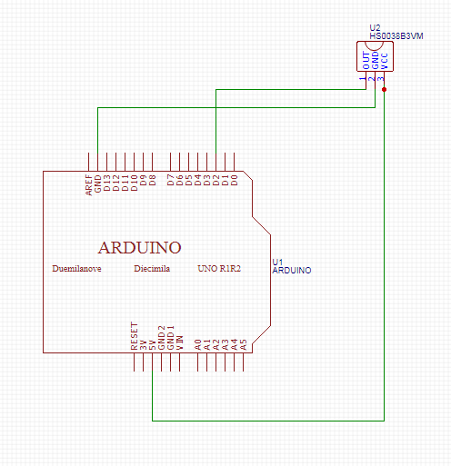

1. **修正程式碼**